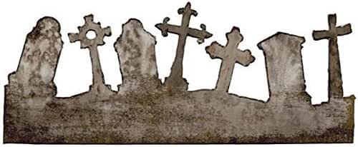

**CEMETERY WALK**

**Saturday, October 7, 2023**

